**Smart Home**

Name and surname: Anton Napolskyi, Vladyslav Varfolomeiev

Group: C5,C6

Components: ESP82666 NodeMCU, humidity and temperature sensor DHT11, card sensor RFID-RC522, sound sensor KY-037, buzzer, RGB LED module HW-479.

The idea of this project was to create an intelligent device that helps monitor the situation of your apartment, provide security with the help of key cards and signaling. The lights in apartment will automatically turn on by the clap and information of temperature and humidity indicators will be send to the server. The “Metadata” function allows you to change the signaling status and lights in home.

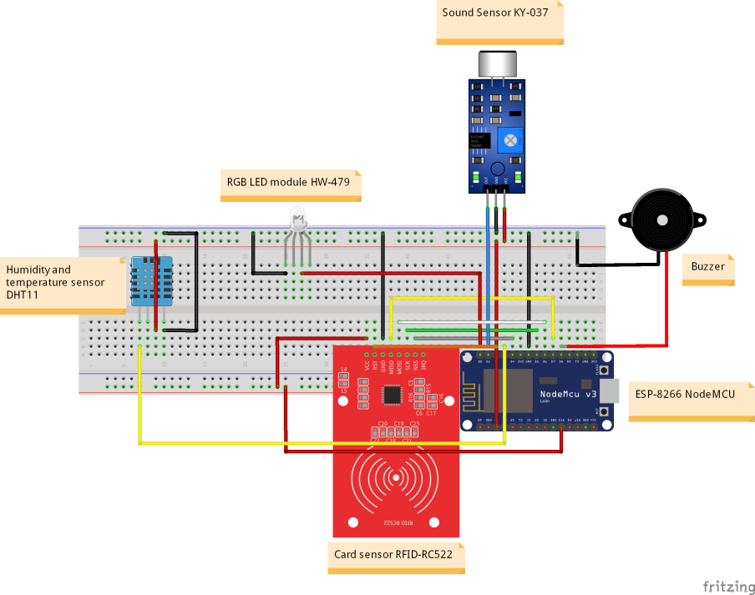

Obrazok 1: Schéma zapojenia jednotlivých komponentov

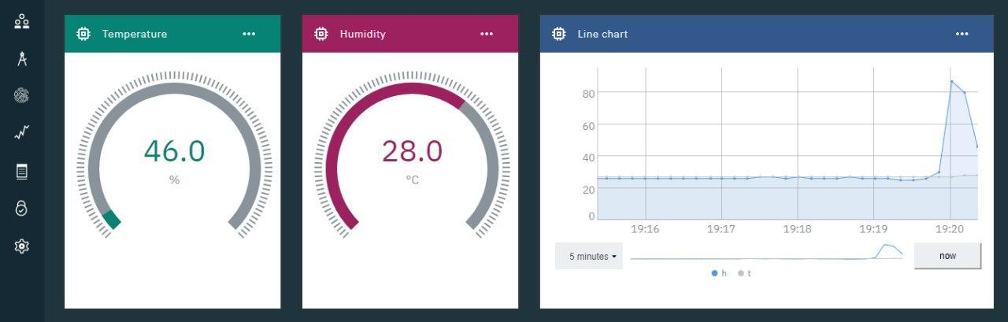

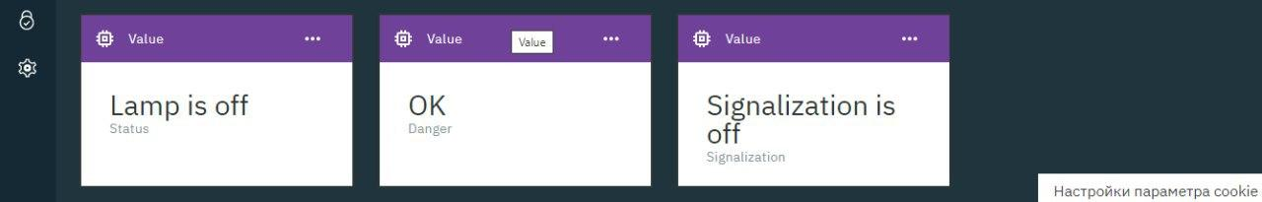

Obrazok 2: Vizualizácia zozbieraných dát